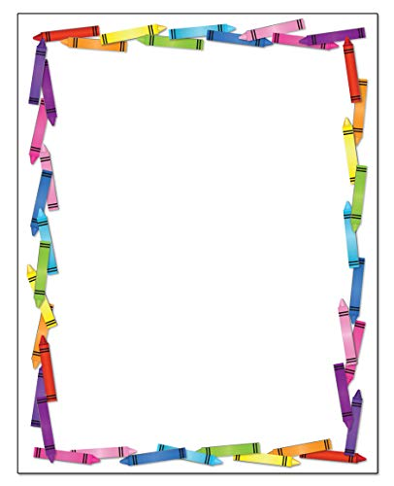

Myself
My name is Melody. I am eight years old. I am a girl.
I am a student. I go to school by school bus.

My favourite food is ice-cream. I like ice-cream because
it is sweet.

I like Mid-autumn festival because I like eating moon
cakes. They are yummy and sweet.

3B Melody Wong

